

**Faculty of Engineering and Technology**

**Electrical and Computer Engineering Department**

**Project 1-Water Temperature Controller-**

**Prepared By:**

**Instructor:**

**TA:**

**Section:**

**Date:**

**Table of Contents**

**Abstract:** 4

**Part1: Description of the Circuit Function andOperation:** 5

**Part2: Circuit Simulation by Orcad Pspice:** 8

**Part3: Circuit Analysis** 18

**Part4: Conclusion** 20

# **Abstract:**

In this project we will learn the principle of a circuit that represents a water temperature controller. The aim of this project is to apply the concepts that we learned in this course. And we will simulate this circuitby the OrcadPspice and we will try to conclude the effect of changing the resistor of the sensor on the temperature of the water in the heater. And we will analysis this circuit theoretically and compare it with the results of OrcadPspice.

# 

# **Part1: Description of the Circuit Function andOperation:**

In this project we have to control the temperature of water and for that purpose we have divided our circuit into three parts. The first part is the wheat stone bridge whose circuit diagram is given below.

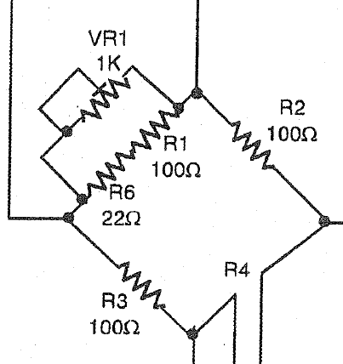

Figure 1-The First Stage of the Project-

The next stage is the instrumentation amplifier and it’s contain a 7 resistor and three op amp as shown in the next figure.VR2 works for changing output voltage according to our desire.

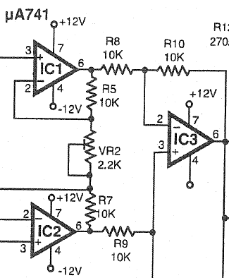

Figure 2-The Second Stage of the Project-

VR2 is a variable resistor and this resistor is to determine the gain of the instrumentation amplifier. And if we look at figure 2, that shows we must biasing each op amp shown in the figure.

Practically the instrumentation amplifier shown in the figure 2 available as a one package.

The third stage of this project is set of eight comparators as shown in the next figure.

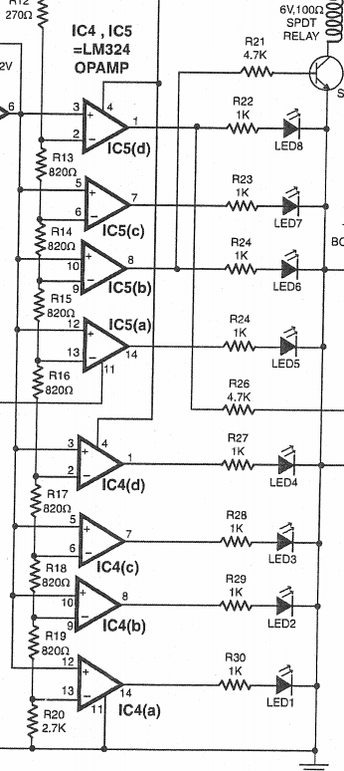

Figure -Third Stage of the Project-

We must note that all the comparators shown in Figure 3 is a nonlinear application of the op amp and it’s working in the saturation region. And each op amp driving to each led (diode).

In practically, the IC5 (a,b,c,d) is available as a one package and also IC4(a,b,c,d) is available as a one package.

In the comparators when V(+)>V(-) , then the led will turn on. And V(+)<V(-), then the led will turn off.

After we talked about the stages of this project, we can talk about of the principle of the circuit of this project shown on the next figure.

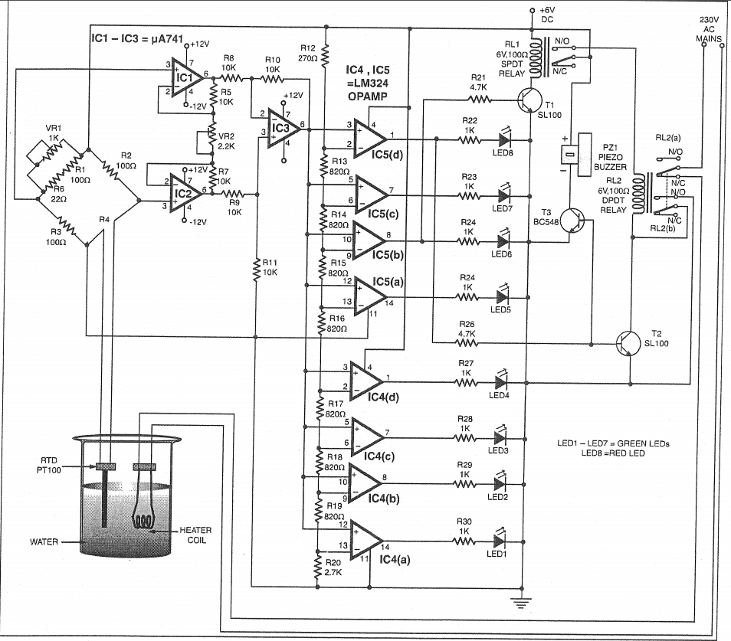

Figure -Circuit Connection-

As we talk, the aim of this project is how to control the temperature of the water in the heater. The heater shown in the figure 4 gets the power from the ac line voltage.

Let now consider that we want to maintain the temperature of the water in the heater between 60 Celsius to 100 Celsius. If the temperature of the water reaches 100 Celsius the heater will turn off, then the temperatureof the water will decreases with the time. After the heater turn off and the temperature decreases with the time and if the temperature be less than the 60 Celsius, then the heater will turn on and then the temperature of the water increases again.

If we look at the Figure 4, the RTD is a sensor called resistor temperature dependent. This resistor dependent on the temperature of the water in the heater.

**Part2: Circuit Simulation by OrcadPspice:**

**Stage 1: Wheatstone bridge:**

**For R=100 ohm:**

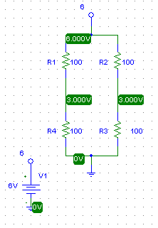

Figure 4-Circuit Simulation of the First Stage When R=100 ohm-

**For R=138.5 ohm:**

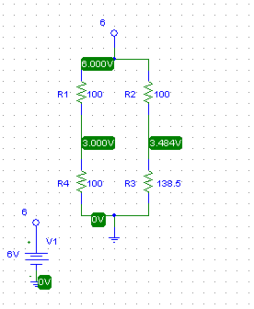

Figure 5-Circuit Simulation of the First Stage When R=138.5 ohm-

**For Rx=120 ohm:**

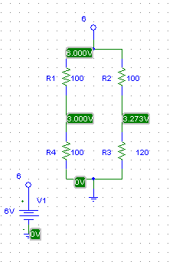

Figure 6-Circuit Simulation of the First Stage When R=120 ohm-

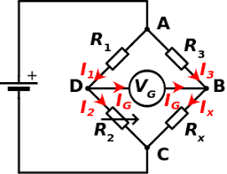

Figure 7-Wheatstone Bridge-

At this stage, we notice that V(at Point D) equal to V(at point B)=3 Volt when R=100 ohm , but when R=120 ohm& R=138.5 V(at point D) still equals to 3 Volt , but V(at Point B)=3.273&3.484 volt respectively.

**Stage 2: Instrumentation Amplifier:**

**Stage 2-A: Find the exact value of the variable resistor to make the output of the Instrumentation Amplifier equals to 6 Volt.**

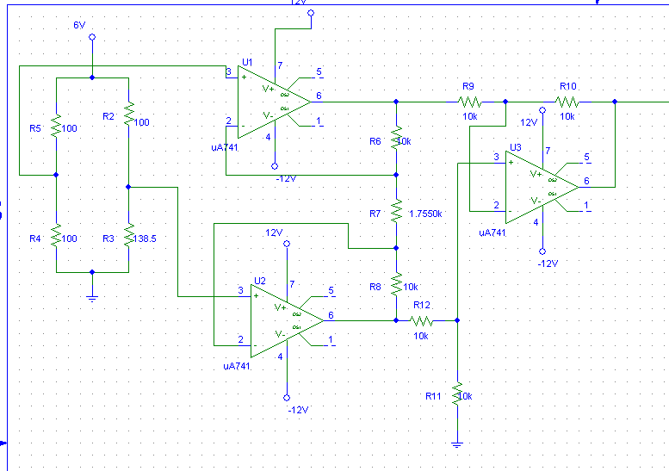

Figure 8-Circuit Connection for instrumentaion amplifier



Figure 9-Simulation at the Output-

From figure 10, we can notice that the value of the variable resistor to make the output of the Instrumentation Amplifier equals to 6 volt is equal to 1.7550k ohm.

**Stage 2-B: Instrumentation Amplifier**

For R=100 ohm:

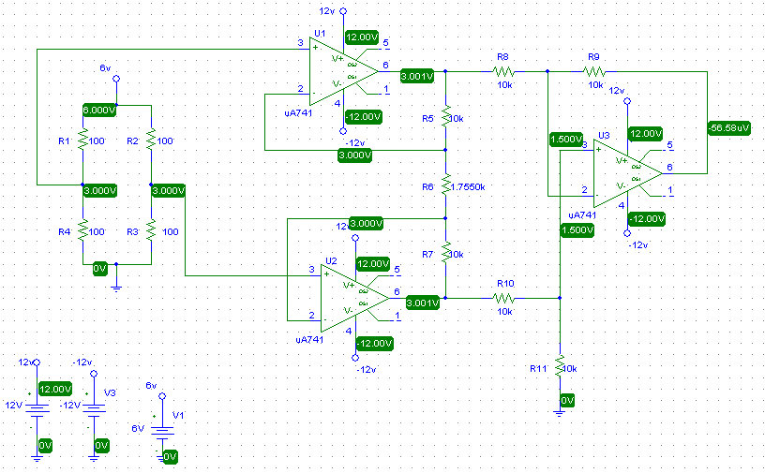

Figure 10-Simualtion R=100 ohm-

For R=138.5 ohm:

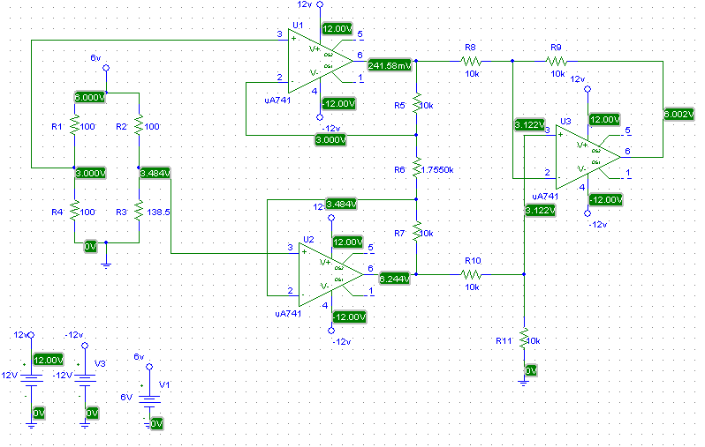

Figure 11-Simualtion R=138.5 ohm-

For Rx=120 ohm:

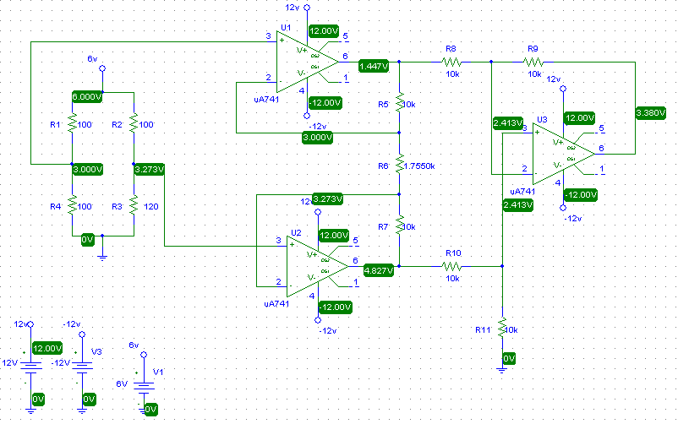

Figure 12-Simualtion when Rx=120 ohm-

In this stage we can notice that when the R(of the sensor) in wheatstone bridge equals to 100 ohm , then the output of the **Instrumentation** amplifier equals to (≈zero) volt, but when R(of the sensor) in wheatstone bridge equals to 120 ohm ,then the output of the instrumentation amplifier equals to 3.380 Volt , but when R(of the sensor) in wheatstone bridge equals to 138.5 ohm ,then the output of the instrumentation amplifier equals to 6.002 Volt.

**Stage 3:Comparator Level Detector**

* **For R=100 ohm:**

**Circuit Connection & Simulation:**



Figure 13--Circuit Connection & Simulation for R=100 ohm-

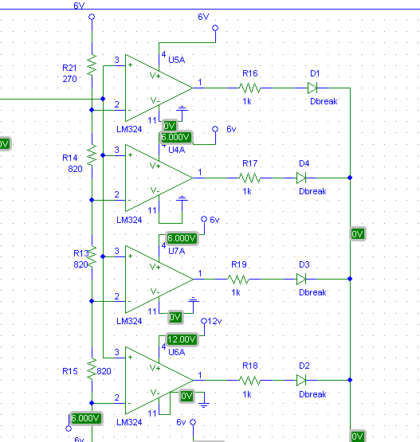

Figure 14-Circuit Connection & Simulation for R=100 ohm-

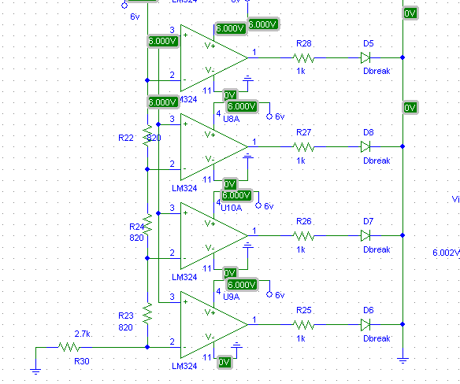

Figure 15-Circuit Connection&Simulation for R=100 ohm-

* **For R=138.5 ohm:**

**Circuit Connection & Simulation:**



Figure 16-Circuit Connection&Simulation for R=138.5 ohm-

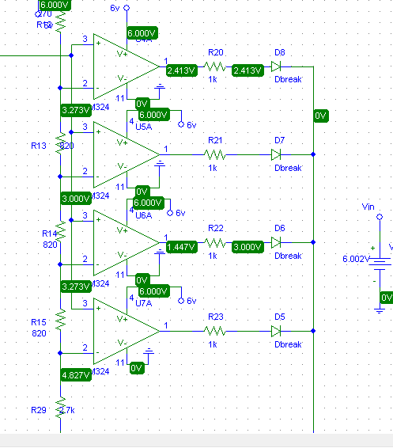

Figure 7-Circuit Connection & Simulation for R=138.5 ohm-

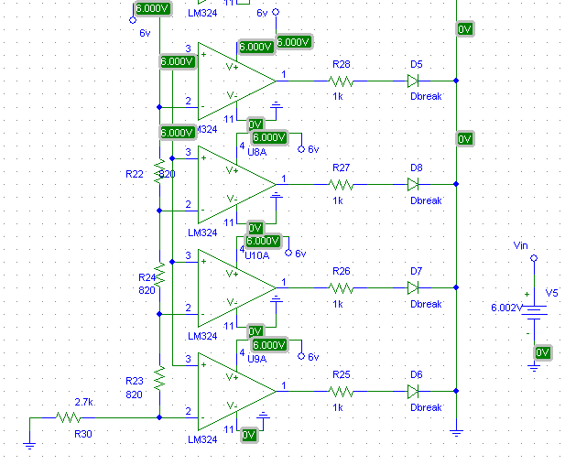

Figure 18-Circuit Connection & Simulation for R=138.5 ohm-

* **For Rx=120 ohm:**

**Circuit Connection & Simulation:**



Figure 19-Circuit Connection& Simulation for Rx=120 ohm-

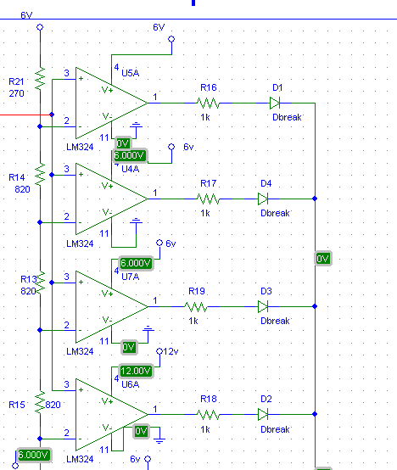

Figure 20-Circuit Connection & Simulation for Rx=120 ohm-

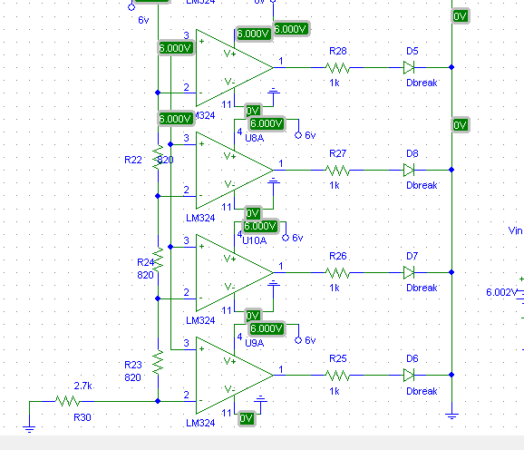

Figure 21-Circuit Connection & Simulation for Rx=120 ohm-

We notice that from the stage 3 when R=100 ohm, then the output of the instrumentation amplifier is equal to (≈Zero) voltage and this leads to be the V(+) less than V(-) and the all resistors have a zero voltages and currents ,then the all LEDs are turn off. But when R=138.5 ohm, the output of the instrumentation amplifier is equal to (6.002 Volt) and this value larger than (6 Volt) and larger than the all voltage divider from the (6 Volt), then (V+)>V(-) and we can notice that the voltages and the currents of the all resistors are not equals to zeros and this means that all LEDs in the circuit are turn on. But when R=120 ohm, we can notice that, the output of the instrumentation amplifier is equal to (3.380 Volt) and we can notice that some comparators have V(+)<V(-) and some resistors have (≈zero) voltages, then this means some LEDs are turn off , but the least three comparators have V(+)>V(-) and at least three resistors have a non-zero voltages and currents, then this means that at least two LEDs are turn on.

**Part3: Circuit Analysis**

**Stage 1: Wheatstone bridge:**

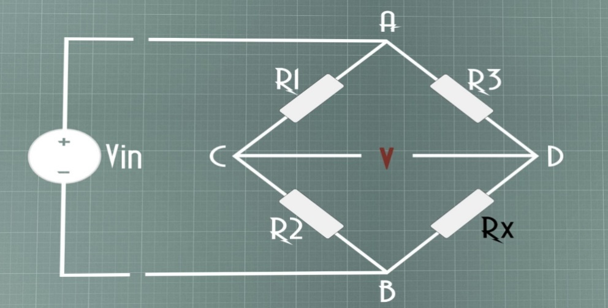

Figure 22-WHEATSTONE BRIDGE-

**V(At Point D)= (Rx(Sensor)*Vin)/ (Rx+R3)**

**V(At Point C)= (R2*Vin)/ (R2+R1)**

**For Rx=120 ohm:**

* V(At Point D)= (Rx(Sensor)*Vin)/ (Rx+R3)
* V(At Point D)= (120*6)/(120+100)
* V(At Point D)= =3.2727 Volt
* V(At Point C)= (R2*Vin)/ (R2+R1)
* V(At Point C)=(100*6)/(100+100)
* V(At Point C)= =3Volt

**For Rx=100 ohm:**

* V(At Point D)= (Rx (Sensor)*Vin)/ (Rx+R3)
* V(At Point D)= (100*6)/(100+100)
* V(At Point D)= =3 Volt
* V(At Point C)= (R2*Vin)/(R2+R1)
* V(At Point C)= =(100*6)/(100+100)
* V (At Point C)= =3Volt

**For Rx=138.5 ohm:**

* V(At Point D)= (Rx (Sensor)*Vin)/ (Rx+R3)
* V(At Point D)= (138.5*6)/(138.5+100)
* V(At Point D)=3.4843 Volt
* V(At Point C)= (R2*Vin)/ (R2+R1)
* V(At Point C)=(100*6)/(100+100)
* V(At Point C)=3Volt

**Stage 2: Instrumentation Amplifier:**

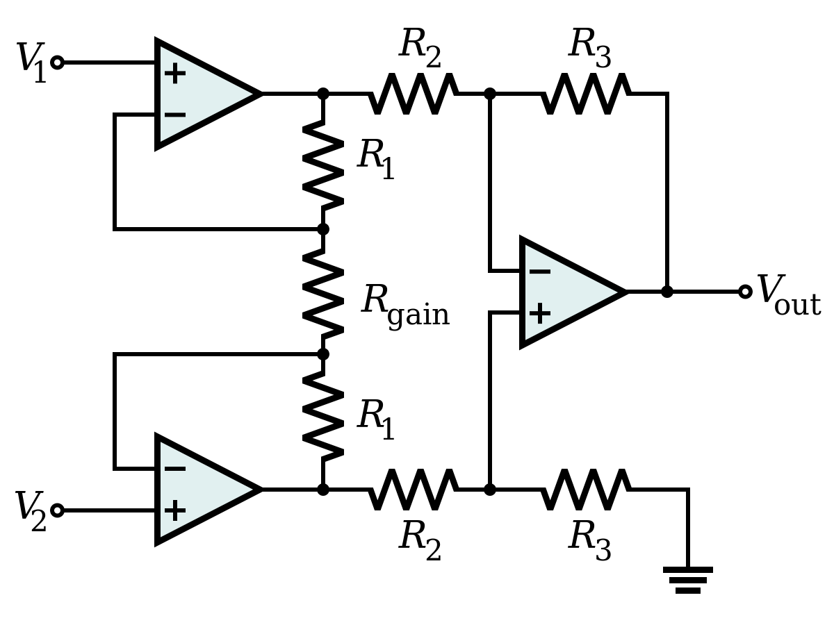

Figure 3-Instrumentation Amplifier-

For instrumentation amplifier we know that

* **Vo=(R3/R2)*(Vo2-Vo1)**
* **Vo =(R3/R2)*(1+(2*R1/Rgain))*(V2-V1)**

**For Rx=100 ohm:**

Vo=(R3/R2)(1+(2R1/Rgain))*(V2-V1

Vo=10k/10k(1+(2*10k/1.7550k))*(3-3)

Vo=0 Volt

**For Rx=138.5 ohm:**

Vo=(R3/R2)(1+(2R1/Rgain))*(V2-V1)

Vo=10k/10k(1+(2*10k/1.7550k))*( 3.4843 -3)

Vo=12.396*0.4843=6.0033 Volt

**For Rx=120 ohm:**

Vo=(R3/R2)(1+(2R1/Rgain))*(V2-V1)

Vo =10k/10k(1+(2*10k/1.7550k))*( 3.2727 -3)

Vo =12.396*0.2727=3.3803 Volt

# **Part4: Conclusion**

After we doing this project by theOrcadPspice, we understood this circuit and all stages of this circuit more better and we understood that the principle of the water temperature is to control the temperature of the water in a specific range of temperature.

We notice that when we increases the resistor of the sensor that’s will lead to increases the voltage of the resistor and the temperature of the water in the heater will increases.

If we compare the results we got from the theoretical and the results from the OrcadPspice, we notice that there is a slightly difference by. This difference is maybe due to the voltage drop across the components of the circuit likethe op amp and may be due to arithmetic errors or programming problems.